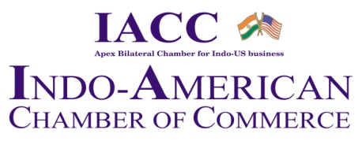
22nd Indo-US Economic Summit

Shaping a Shared Future: India-US Collaboration for Global Resilience
Wednesday, 17th September 2025, 10:00 am - 6:30 pm, New Delhi

REGISTRATION FORM

I/we would like to join the 22nd Indo-US Economic Summit 2025,

Details:

Name ______________________________________________________

Designation ______________________________________________________

Company’s name ______________________________________________________

Company Address______________________________________________________

Telephone no(s) ______________________________________________________

Mobile no. ______________________________________________________

Email id (s) ______________________________________________________

Website ____________________________________________________ _

The Secretariat
Indo-American Chamber of Commerce, NIC
Room no. 403, 4th Floor |PHD House, | 4/2 Sri Institutional Area | August Kranti Marg | New Delhi 110016
Tel +91-8826130082
Email : Kashish.tyagi@iaccindia.com; neelu@iaccindia.com; sonia@iaccindia.com | Web: www.iaccindia.com

