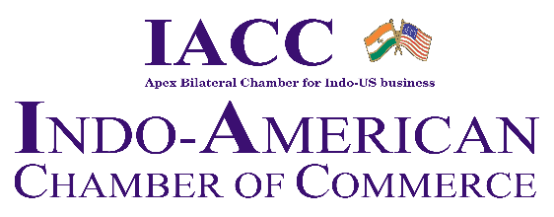
Co- Partner
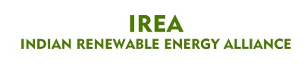

North India Council
3rd Energy Summit
Integrated Energy Pathways for a Secure & Sustainable, Low-Carbon Future

Thursday, 24th July 2025, Time: 10:00 am – 5:00 pm, New Delhi

REGISTRATION FORM

I/we would like to join the 3rd Energy Summit on 24th July 2025,

Details:

Name ______________________________________________________

Designation ______________________________________________________

Company’s name ______________________________________________________

Company Address______________________________________________________

Telephone no(s) ______________________________________________________

Mobile no. ______________________________________________________

Email id (s) ______________________________________________________

Website ____________________________________________________ _

Participation Fee (Inclusive Taxes): Rs 3000/-
Rs.500/- Early Bird Discount on participant registration before 11th July 2025

Payment options:

NEFT:
Bank Name: | State Bank of India
Branch: | ASIAN GAMES VILLAGE
Bank Address | ASIAN GAMES VILLAGE, NCUI  3 SIRI INSTITUTIONAL AREA,  AUGUST KRANTI MARG  NEW DELHI-110016
Branch Code: | 07407
IFSC Code: | SBIN0007407
Company Name: | Indo American Chamber of Commerce
Account Status | Current Account
Account No.: | 30667839353
PAN NO.: | AAAAI0063L

Date: ___________________________

Place: ___________________

Signature: ________________ __

The Secretariat
Indo-American Chamber of Commerce, NIC
Room no. 403, 4th Floor |PHD House, | 4/2 Sri Institutional Area | August Kranti Marg | New Delhi 110016
Tel +91-8826130082
Email : Kashish.tyagi@iaccindia.com; neelu@iaccindia.com; sonia@iaccindia.com | Web: www.iaccindia.com

