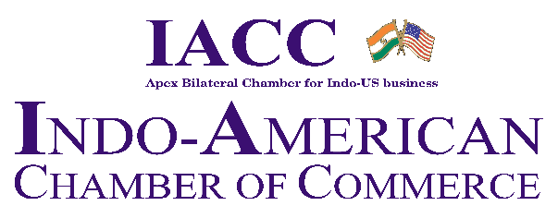
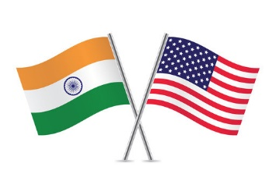

North India Council
IACC Delegation to USA
22nd June 2024 to 2nd July 2024
Maryland, New York & Washington DC

REGISTRATION FORM

To,

The Secretariat
Indo-American Chamber of Commerce
Room no. 403, 4th Floor, PHD House, 4/2 Sri Institutional Area
August Kranti Marg | New Delhi 110016

Dear Sir/Madam,

Delegate Details:
Name __________________________________________________

Designation __________________________________________________

Company’s name ___________________________________________________

Company Address ___________________________________________________

Telephone no(s) ____________________________________________________

Mobile no.

Email id (s)

Website

Passport Details

Name as per Passport
Passport No.
Passport Expiry date
DOB (MM/DD/YYYY)
Visa Status
Pan Card No. | GST No.

Business profile of your organization (not more than 150 words):

Business objectives for visiting the USA:

Product Area of interest for meetings in USA:

Meal Preference

Veg: Non-Veg:

Travel Arrangements:

To assist you with your travel arrangements, including airfare, hotel accommodation, visa and travel insurance coordination, we will provide you with the contact details of our designated travel agent. They will be able to assist you in making the necessary arrangements for your travel and stay.

Visa Assistance:
As part of your registration, we offer visa assistance to registered participants, providing guidance and support to facilitate the visa application process. Our team will provide the necessary documentation and assistance to help streamline the visa application and approval process.

US Visa fee = INR 15,500/- per person
Management fee = INR 3,000/- per person

Registration fee for the Delegation

Members | INR 75000+ 18% GST
Non-Members | INR 85000+ 18% GST
Accompanying Spouse | INR 50000+ 18% GST
US Delegate | $600+ 18% GST

Additional fees to participate in the 10th SelectUSA Investment Summit

Regular Rate - USD $1,290.00
Onsite Rate - USD $1,440.00: 22nd June - 26th June 2024
I/we would like to join the (Please tick)

IACC Delegation to USA

10th SelectUSA Investment Summit

Both Above ____________________________________

All other expenses (international airfare, visa fees, travel insurance, domestic/local travel, accommodation, food, etc.) are to be paid by the delegate as per the actuals.

The above registration fee includes:

- Meetings with Government officials from India and USA: Depending on availability and scheduling, registered participants may have the chance to meet and interact with Government officials from India and USA. These meetings can offer valuable networking opportunities and foster connections at the governmental level.

- Meetings with U.S. Economic Development Organizations (EDOs), Business/Factory Visits: participants will have the opportunity to participate in exclusive business or factory visits. These visits will provide an actual understanding of local industries, manufacturing processes, and business operations.

Other Administrative Costs

GENERAL PROCEDURES:

- All other expenses (international airfare, visa fees, travel insurance, domestic/local travel, accommodation, food, etc.) are to be paid by the delegate as per the actuals.

- In case delegation is canceled by IACC then Registration Fee will be refunded after deduction of actual cost, if any.

- In case of cancellation by the delegate, the refund would be:
- 75% prior to 40 days of the delegation date;
- 25% prior to 30 days of the delegation date;
- No refund if less than 30 days of the delegation date.

- In case the visa is non-granted, 25% will be retained from the registration fees and the rest will be refunded.
- Total cost of the travel expenditure per delegate will be informed once we know the actual number of registered participants.
- IACC reserves the right to cancel and or change the delegation process at any stage without assigning any reason.
- IACC reserves the right to accept or reject any or all the applications received at its discretion, without assigning any reason whatsoever.
- Please provide the following along with the registration form:
- Brief profile of your organization
- Purpose of your visit with specific areas of business interests/collaboration that you are looking for
- Delegate’s PAN Card copy
- Delegate’s Passport copy
- Recent passport-size photograph
- GST certificate for raising invoice towards registration fees

Payment options:

DD/ Cheque no.____________________ dated __________________drawn in favor of Indo-American Chamber of Commerce, Payable at New Delhi

NEFT:
Bank Name: | State Bank of India
Branch: | ASIAN GAMES VILLAGE
Bank Address | ASIAN GAMES VILLAGE, NCUI  3 SIRI INSTITUTIONAL AREA,  AUGUST KRANTI MARG  NEW DELHI-110016
Branch Code: | 07407
IFSC Code: | SBIN0007407
Swift Code: | SBININBB382
Company Name: | Indo American Chamber of Commerce
Account Status | Current Account
Account No.: | 30821328242
PAN NO.: | AAAAI0063L

Date: ___________________________ Place: ___________________ Signature: __________________

