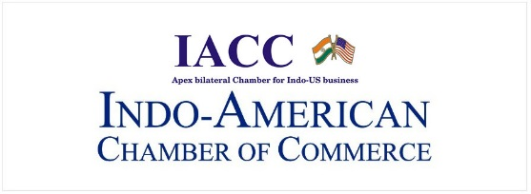
“Emerging Risks & Solutions for Global Corporations”

Wednesday, January 30, 2019 |Hotel Taj Mahal Palace, Mumbai

Registration Form

Name Designation

Organization:

Address:

___________________________________________________________________________________

Tel: Mob: __________

Email id:

Brief Company Profile:

______________________________________________________________________________________________
________________________________________________________________________________________________________________________________________________________________________________________________________________________________________________________________________________________________________________________________________________________________________________________
Knowledge Partner

* For further information and updated programme, please contact The Secretariat
Indo-American Chamber of Commerce
1-C, Vulcan Insurance Building, Veer Nariman Road, Churchgate, Mumbai 400 020
Tel : 9975532783 ; Email: archana.kolte@iaccindia.com

